**DAILY ONLINE ACTIVITIES SUMMARY**

|  |  |  |  |  |  |  |  |  |
| --- | --- | --- | --- | --- | --- | --- | --- | --- |
| Date: | 2/06/2020 | | | | | Name: | Jyothi B R | |
| Sem & Sec | IV-A | | | | | USN: | 4AL18CS030 | |
| Online Test Summary | | | | | | | | |
| Subject | | ------ | | | | | | |
| Max. Marks | | -- | | Score | | | -- | |
| Certification Course Summary | | | | | | | | |
| Course | Programming Essentials in Python | | | | | | | |
| Certificate Provider | | | Cisco Virtual Academy | | Duration | | | 2.5hrs |
| Coding Challenges | | | | | | | | |
| Problem Statement.1. Write a Java program to find Perfect Sum Problem.  2. Write a program in java, an array of integer data to be initialized. | | | | | | | | |
| Status:Completed | | | | | | | | |
| Uploaded the report in Github | | | | | Yes | | | |
| If yes Repository name | | | | | https://github.com/alvas-education-foundation/jyothi_b_r | | | |
| Uploaded the report in slack | | | | | Yes | | | |

Online Test Details: (Attach the snapshot and briefly write the report for the same)

Certification Course Details: (Attach the snapshot and briefly write the report for the same)

Coding Challenges Details: (Attach the snapshot and briefly write the report for the same)

**ONLINE TEST DETAILS**: -Not conducted.

CERTIFICATION COURSE DETAILS:

Programming Essentials in Python :

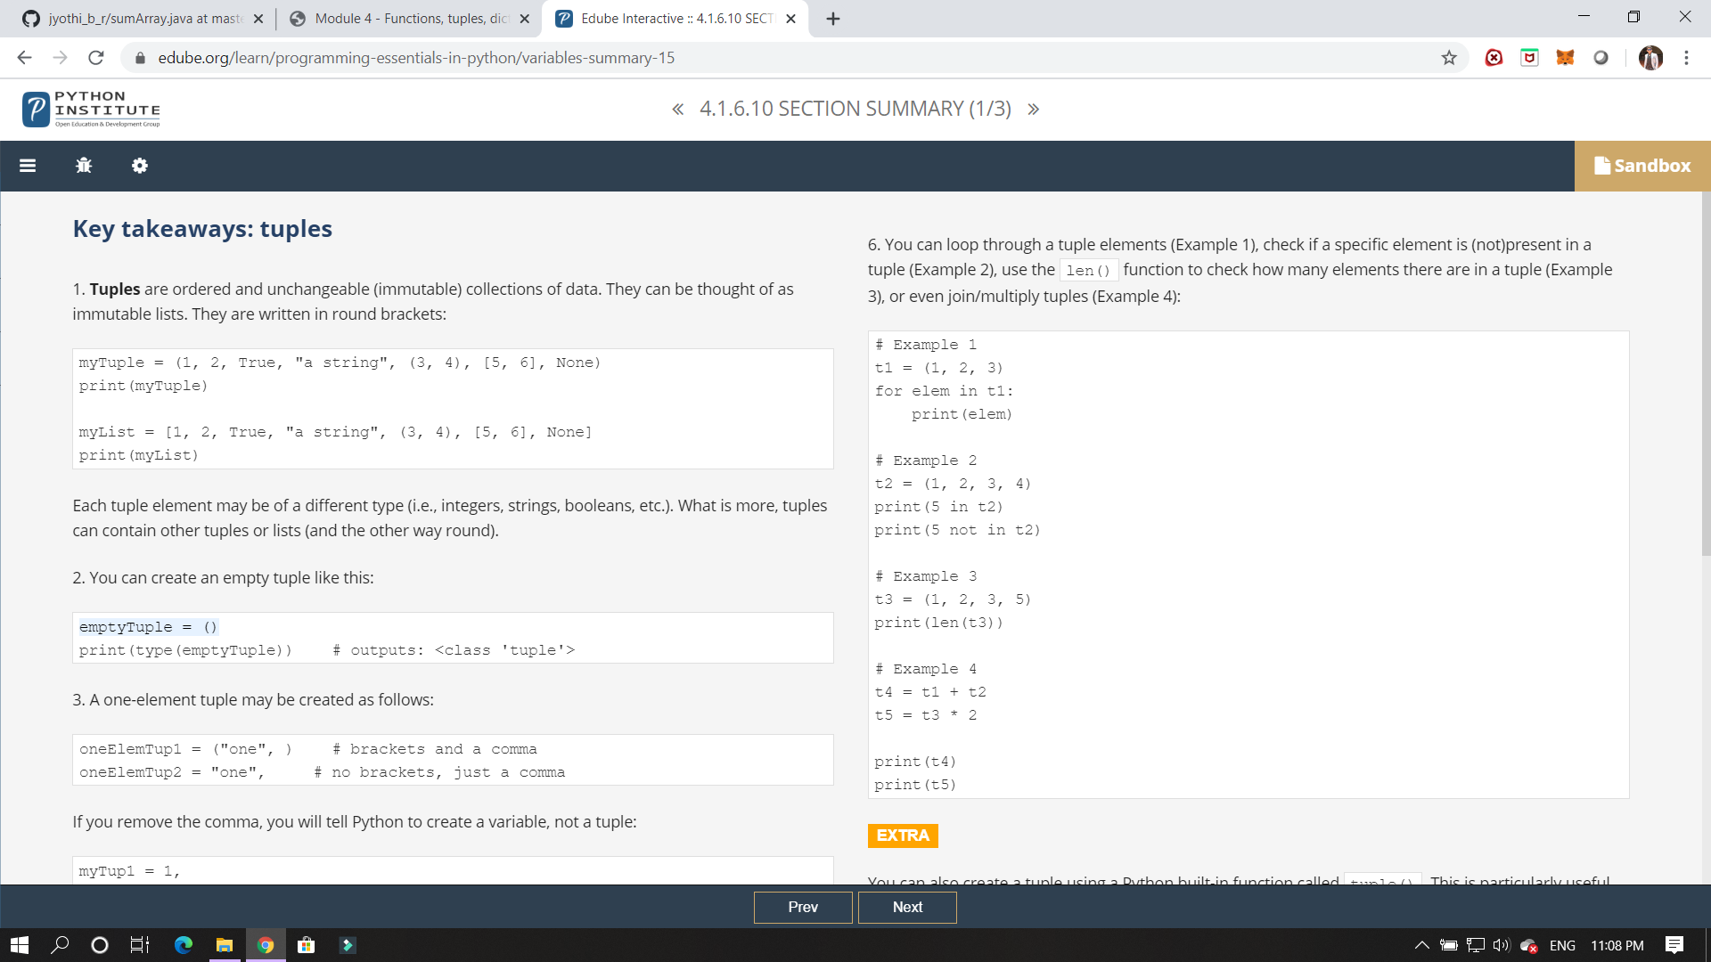

In this class I have studied about tuples and to classify it and some of its applications.

ONLINE CODING:

Given an array arr[] of integers and an integer K, the task is to print all subsets of the given array with the sum equal to the given target K.

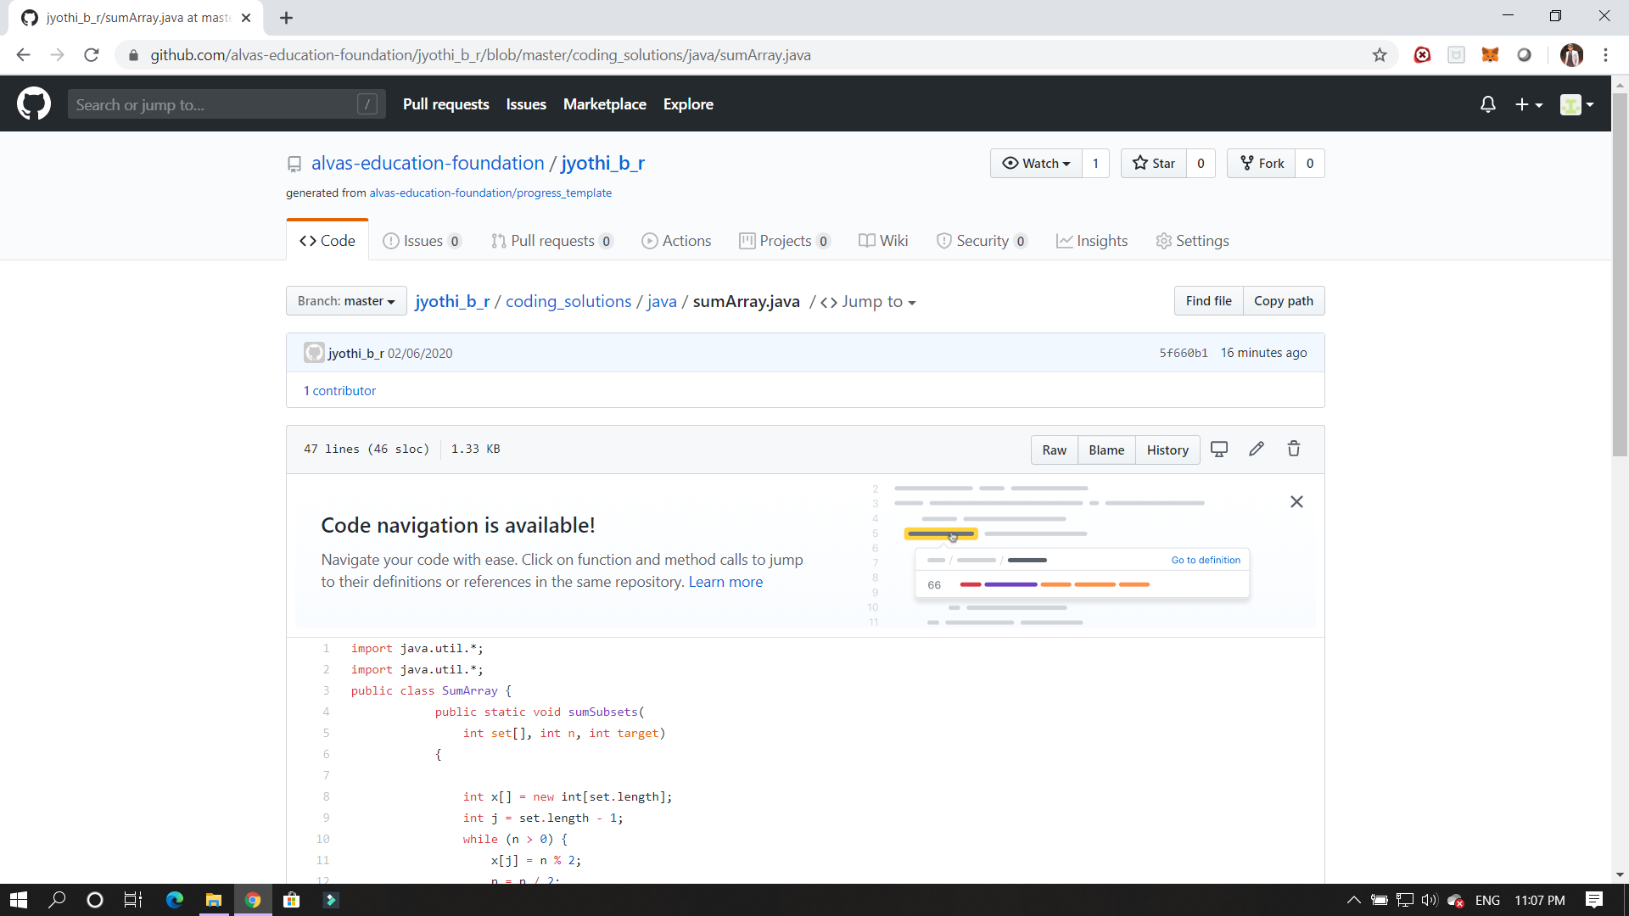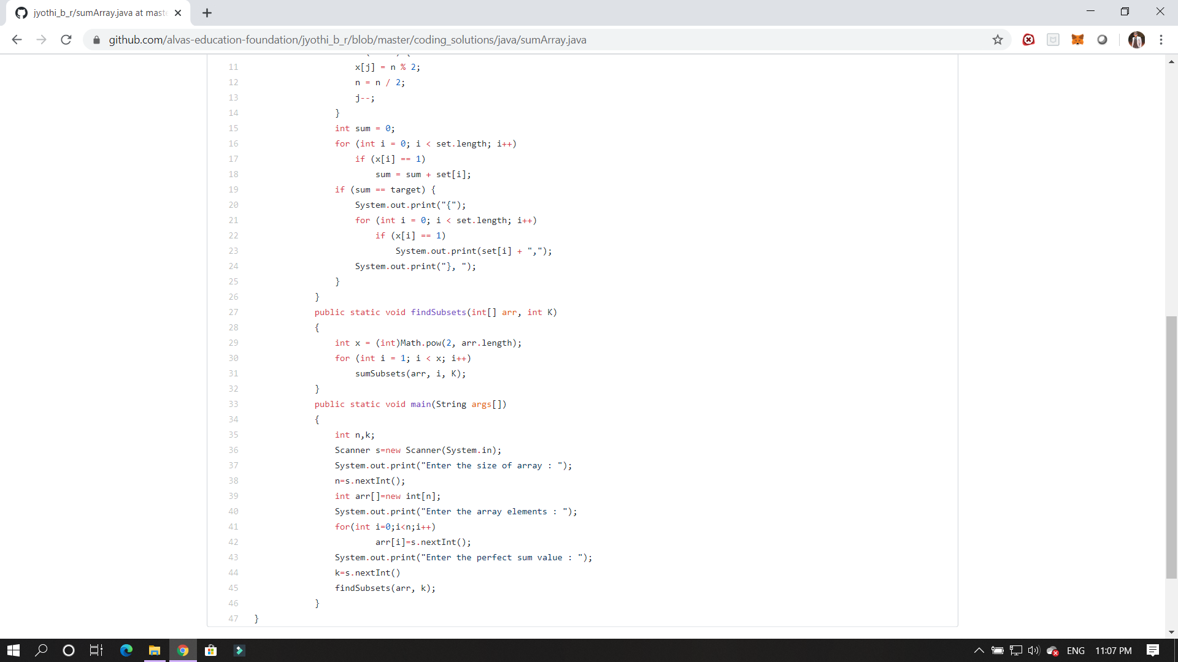

2.  Write a program in java, an array of integer data to be initialized. During the initialization, if a user enters a value other than integer value, then it will throw InputMismatchException exception. On the occurrence of such an exception, your program should print “You entered bad data.” If there is no such exception it will print the total sum of the array.

